

***D.H.S.C. Club Dinghy Championships Saturday 6th September ‘25*  
Briefing at 14.00. First Gun 15.00 (which is the 5 minute signal for the first race ) subsequent races will be called via megaphone warning for following races**

**Notice of Race & Sailing Instructions (N.O.R. & S.I.)**

In the case of a conflict between the SI and RRS (Racing Rules of Sailing), then the S.I. shall overrule and apply.

1. **Organising Authority**

Dungarvan Harbour Sailing Club

1. **Communication for Races**

Through the [D.H.S.C. website](https://dhsc.ie/summer-racing/) & the D.H.S.C. Racing Whatsapp.

1. **Number of Races in the Schedule**

We will look to provide a minimum of 3 races, with an expectation of 6 actual races to take place. If we get to 5 races a Discard system will be introduced for 1 race (slowest time/race is discarded for all competitors). Weather, Time and Tide dependent.

1. **Race Course & Location**

Fig 1 – See Sail Area:

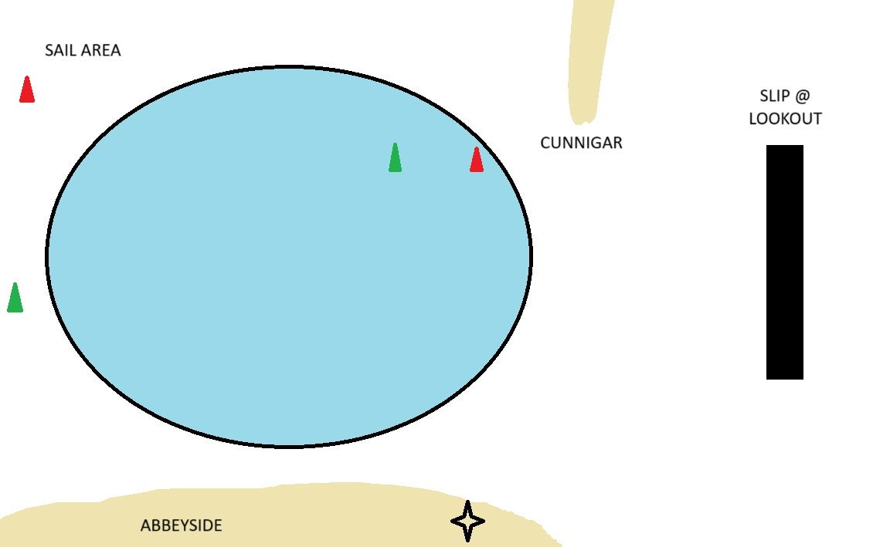

**Race Course & Location Continued**

Fig 2 - Race Course Example:

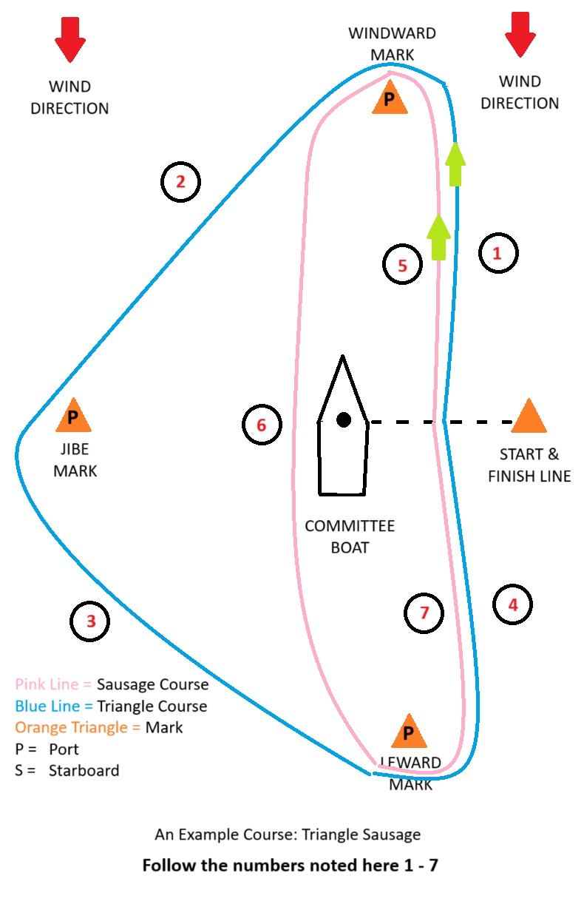

1. **Signals from O.O.D. (Officer of the Day)**

Racing Flag used will be as follows “Fig3”:

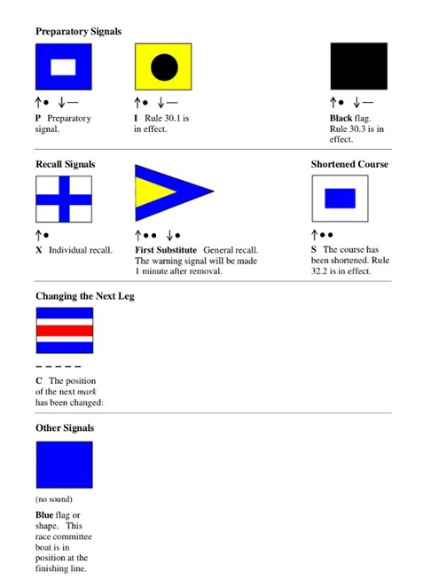

The Committee boat may be identified by a vertical red and white mast and club ensign (Blue)

1. **Starting Procedure and Finishing Line**

The starting line will be between a red and white pole on the Committee Boat and the start mark and will be to leeward of the windward mark. The Race Committee, may, until the Preparatory Signal, adjust the Starting Line, Course Marks or Committee Boat to provide the best possible course.

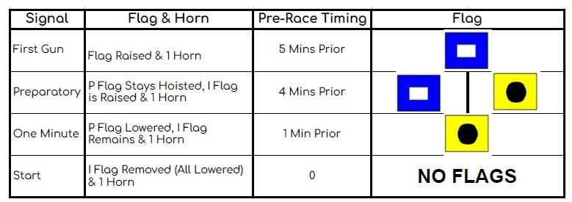

The finishing line will be between the red and white pole on the Committee Boat displaying a blue flag and the finishing mark.

Boats shall keep clear of the starting line until their warning signal. Boats shall not interfere, impede or hinder in any way the start of other classes. The Race Committee may, without a hearing, disqualify a boat that infringes these Sailing Instructions.

Where possible, a short sound signal may indicate your boat has finished racing.

Boats that have finished racing MUST clear the finishing area expeditiously.

**The end of a race**

Shall be denoted by a long blast of the horn.

Each race will last for a maximum of 30 minutes.

Should you not finish within the 30 minute race period, you will be given a DNF (Did Not Finish)

**Should another race be run**

You can expect the next 5 minute warning signal and display of the preparatory flag will be within the following 10 minute period.

1. **Recalls**

**Individual Recall** - Will be denoted by an X Flag or by a Call on the Mega Phone (as shown above Fig3)

This will be followed by 1 long blast on the starter horn.

**General Recall** - Will be denoted by the First Substitute Pennant/Call on a Mega Phone (as shown above Fig3)

This will be followed by MULTIPLE short blasts on the starter horn.

1. **Handicaps & Scoring**

Scoring will be the Low Point System and places will be calculated using the Portsmouth Yardstick handicap system based on the time of each boat to sail the course.

We will also, as racing matures, assign an ECHO club handicap. This will be done to help sailors improve their individual skills and will allow us to highlight sailing improvement by individuals.

1. **Entry & Eligibility**

All permanent helms and crew must be a member of DHSC. Guests are permitted for a maximum of 3 races after which they must become members. These boats are not eligible for inclusion in the overall results in the series.

All boats must register to take part in a race by completing the online registration form a minimum of 12 hours prior to each race start. This form may be found on the DHSC website or on the DHSC Dinghy Racing Whatsapp.

Any boats appearing on the race course that have not completed this form will be deemed not to be racing and will not be given a result.

**INSURANCE**

All boat owners MUST have their own dinghy insurance.

**ENTRY FEES**

There is NO CHARGE for a member of Dungarvan Harbour Sailing Club for entry into the Club Championships. (**MAX 2 Persons per Boat**) The use of club boats is STRICTLY on a first come/first served basis and costs €15 per boat.

Entry form (including payment link for boat hire **NO CASH**) available on the DHSC dinghy racing Whatsapp and through D.H.S.C. website.

**Prize Giving & Awards**

We expect to hold the prize giving after the event in the Clubhouse and welcome all competitors, friends and family members to join us.